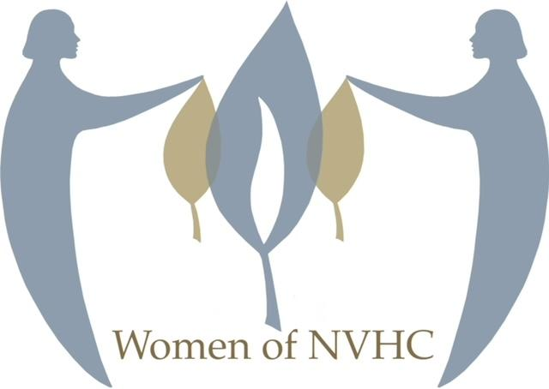

Women of NVHC Membership Form
Join us for exciting and interesting educational programs, social events and just plain fun.

Name: ________________________________________________________________________

Address: ______________________________________________________________________

City: ___________________________________ State: ______________ Zip: ______________

Home Phone: ______________________________ Cell: _______________________________

Email Address: _________________________________________________________________

Birthday: (month and day) ___________________________

Annual Membership Dues:
$_____ New NVHC Temple Member July 1, 2025-2026 - $0
$_____ NVHC Temple Member Dues - $40
$_____ NOT an NVHC Temple Member - $60
$_____ Additional Donation Amount
$_____ TOTAL

Method of Payment: ___ Check Attached (please do not send cash in the mail)
___ On-Line: Pay thru SQUARE: https://square.link/u/Tzhi4eVG

(Please use this link so that dues and donations are processed for WONVHC) (No one is turned away. Contact us by email for any concerns.)

Are you an NVHC member? ___Yes ___No

If not paying on-line, please mail checks and completed forms to: Women of NVHC
1441 Wiehle Ave
Reston, VA 20190

For questions concerning membership and/or dues please contact WomenofNVHC@NVHCReston.org.

Your dues go directly to the operating budget of Women of NVHC. Programs and projects supported by us include summer camp scholarships; B’nai Mitzvah, Confirmation, Conversion & Baby Gifts; and more.
Please provide your interests on this form. Would you like to get involved and help us with an activity? Do you have special interests and talents that you will share? Your preferences are important! Please take the time to let us know your interests and where you can help. Thank you! __________________
______________________________________________________________________________________

